GTPlot Metadata Tables Overview

The GTPlot metadata gives the GIS Administrator the ability to create and modify Map Products. All map products are defined using metadata stored in Oracle tables therefore GIS system administrators can easily Name, Rename, Save, Copy or Delete map products using SQL.

Changes to GTPlot Map Products are done by manipulating the following GT_PLOT_* metadata tables that drive the **Plot Boundary** placement technique and **New Plot Window** custom command.

**GT_PLOT_PARAMETER** – Defines a number of parameters used by the GTPlot software.

**GT_PLOT_SHEETS** – Defines the different sheet names, sizes and their dimension.

**GT_PLOT_DRAWINGINFO** – Defines each drawing type with each sheet definition, default scale and inset defining the plot border.

**GT_PLOT_GROUPS_DRI** – Defines the redlines, mapframes and OLE object to include for each drawing type along with the placement of each.

**GT_PLOT_REDLINES** – Defines groups of redlines (Title Block, Revision History, Legend, Source Document Info)

**GT_PLOT_MAPFRAME** – Defines Map frame and Keymap size, location and north arrow

**GT_PLOT_OBJECTS** – Defines objects to be embedded into the plot (Logo)

# GT_PLOT Metadata Tables ER Diagram

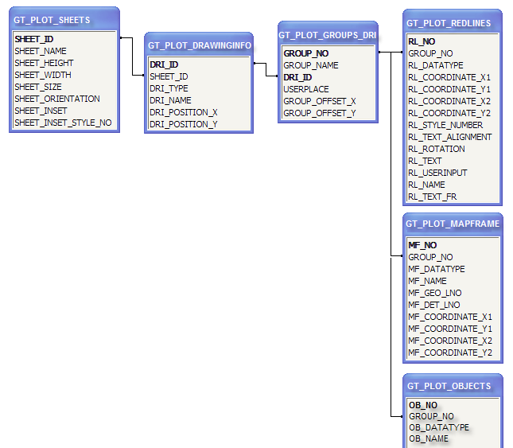

# Sample GTPlot Metadata Tables

## GT_PLOT_PARAMETER

Defines a number of parameters used by the GTPlot software  
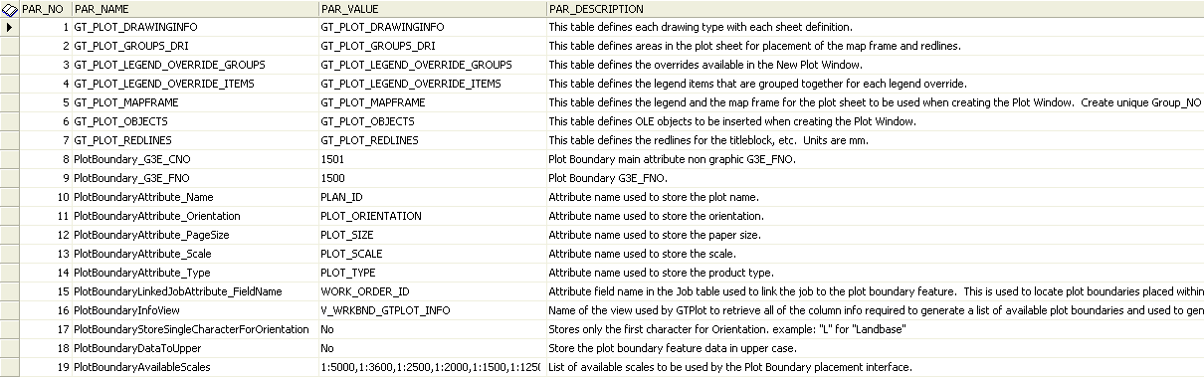

## GT_PLOT_SHEETS

Defines the different sheet names, sizes and their dimension

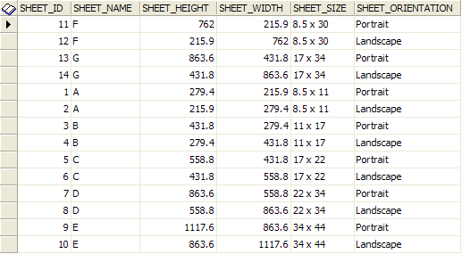

## GT_PLOT_DRAWINGINFO

Defines each drawing type with each sheet definition, default scale and inset defining the plot border

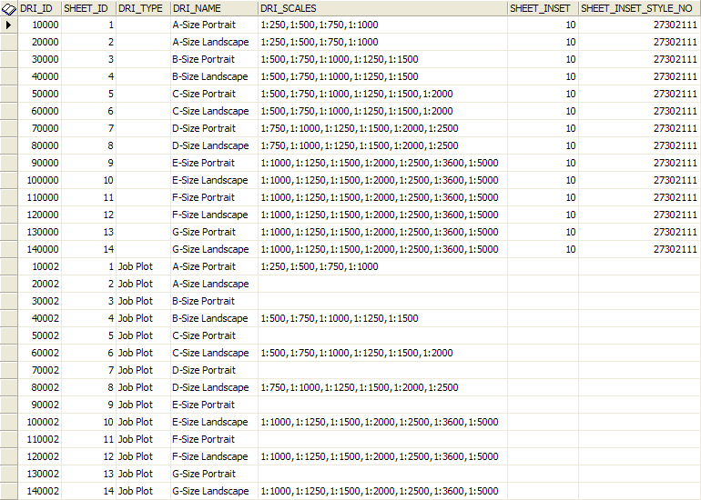

## GT_PLOT_GROUPS_DRI

Defines the redlines, mapframes and OLE object to include for each drawing type along with the placement of each

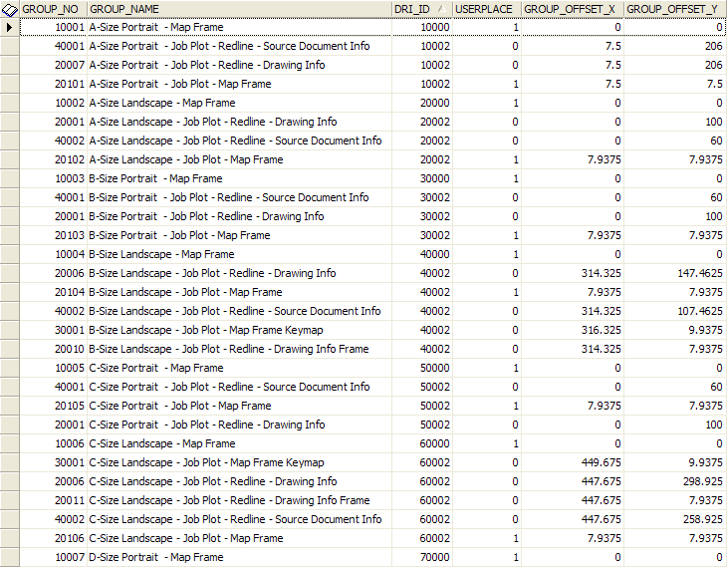

## GT_PLOT_REDLINES

Defines groups of redlines (Title Block, Revision History, Legend, Source Document Info)

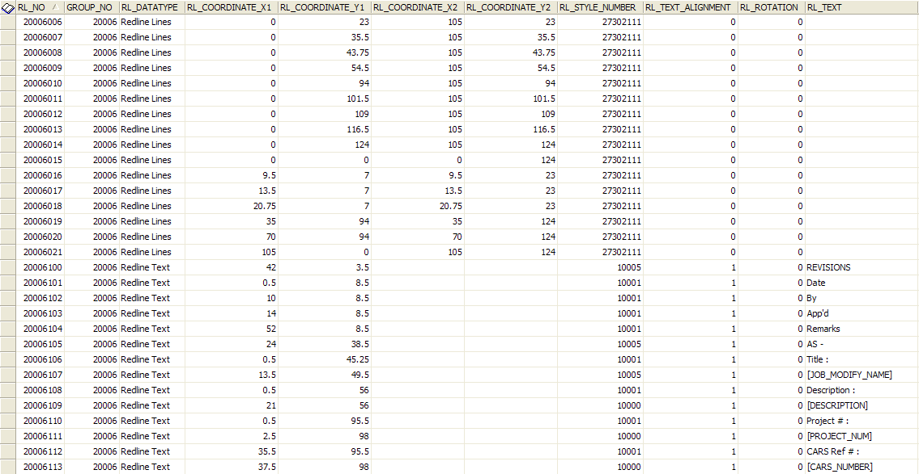

## GT_PLOT_MAPFRAME

Defines Map frame and Keymap size, location and north arrow

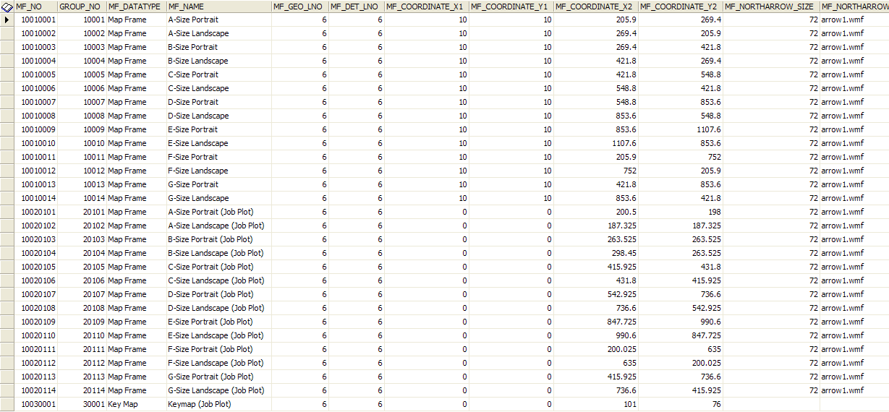

## GT_PLOT_OBJECTS

Defines objects to be embedded into the plot (Logo)

